Coronavirus disease 2019 (COVID-19)
Situation Report – 33

Data as reported by 10AM CET 22 February 2020*

HIGHLIGHTS

- Two new countries (Lebanon and Israel) reported cases of COVID-19 in the past 24 hours.

- The role of environmental contamination in the transmission of COVID-19 is not yet clear. On 18 February, a new protocol entitled “Surface sampling of coronavirus disease (COVID -19): A pr a c t ic a l “ how t o” pr ot oc ol for hea lt h care and public health professionals” was published. This protocol was designed to determine viable virus presence and persistence on fomites in various locations where a COVID-19 patient is receiving care or isolated, and to understand how fomites may play a role in the transmission of the virus.

- The WHO Director-General briefed the emergency ministerial meeting on COVID-19 organized by the African Union and the Africa Centres for Disease Control and Prevention. Details can be found here.

SITUATION IN NUMBERS
total and new cases in last 24 hours

Globally
77 794 confirmed (599 new)

China
76 392 confirmed (397 new)
2348 deaths (109 new)

Outside of China
1402 confirmed (202 new)
28 countries (2 new)
11 deaths (3 new)

WHO RISK ASSESSMENT

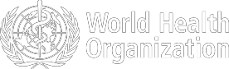
China | Very High
Regional Level | High
Global Level | High

Figure 1. Countries, territories or areas with reported confirmed cases of COVID -19, 22 February 2020
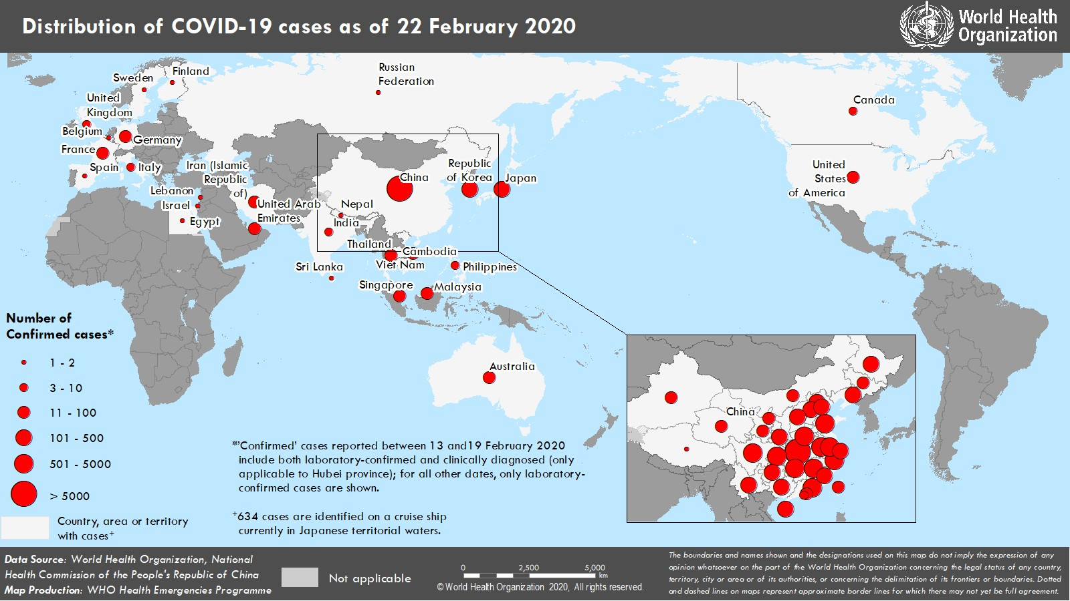
*The situation report includes information provided by national authorities as of 10 AM Central European Time

SUBJECT IN FOCUS: Ne w protocol for Early Epide miologic and Clinical Inv e stigations for Public He alth Re sponse
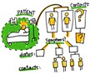

The understanding of transmission patterns, severity, clinical features and risk factors for COVID-19 is currently limited among the general population, among health care workers, in households and in other “closed” settings.

On 18 February, a new master protocol entitled “Surface sampling of coronavirus disease (COVID -19): A practical
“h o w t o ” p ro t o c o l fo r h ea lt h c a re a n d p u b lic h ea lt h p ro f essionals”was published.

The role of environmental contamination in the transmission of COVID-19 is not yet clear. This protocol was designed to determine viable virus presence and persistence on fomites in various locations where a COVID-19 patient is receiving care or isolated, and to understand how fomites may play a role in the transmission of the virus in these settings. It is important that surface sampling is done as part of a comprehensive outbreak investigation, and that information obtained by environmental studies is combined with findings from epidemiological and laboratory investigations.

As a reminder, several early investigation master protocols and master forms for COVID-19 are available:

Early Epidemiologic and Clinical Investigations
for Public Health Response
 | Setting | For whom? | Which protocol should be used? | Contact details for further information
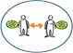 | Community transmission mainly (or closed settings) | Cases and close contacts in the general population  or can be restricted to close settings (like households, health care settings, schools). | The First Few COVID-19 X cases and contacts transmission investigation protocol (FFX) | EarlyInvestigations-2019- nCoV@who.int
 | Households  transmission | Cases and close  contacts in households setting | Households transmission of  COVID-19 investigation protocol (HH) | EarlyInvestigations-2019-  nCoV@who.int
 | Health facilities transmission | For health workers in a health-care setting in which a confirmed case has received care | Assessment of COVID-19 risk factors among Health workers (HW) protocol | EarlyInvestigations-2019- nCoV@who.int
 | Surface  contamination and transmission | For environmental  surfaces | Surface sampling of COVID-  19: A practical “how to” protocol for health care and public health professionals | EarlyInvestigations-2019-  nCoV@who.int
 | Clinical  characterization | For hospitalized  cases | Global COVID-19 clinical  characterization case record form, and data platform for anonymized COVID-19 clinical data | EDCARN@who.int

For more information, visit: https://www.who.int/emergencies/diseases/novel-coronavirus- 2019/technical -guidance/early-investigations




SURVEILLANCE

Table 1. Confirmed and suspected cases of COVID-19 acute respiratory disease reported by provinces, regions and cities in China, 22 February 2020

Province/ Region/ | Population (10,000s) | Confirmed | Daily  Suspected |  | Cumulative  Confirmed Deaths
City | cases |  | cases | Deaths | cases
Hubei | 5917 | 366 | 1125 | 106 | 63454 |  | 2250
Guangdong | 11346 | 6 | 1 | 0 | 1339 |  | 5
Henan | 9605 | 3 | 25 | 0 | 1270 |  | 19
Zhejiang | 5737 | 2 | 4 | 0 | 1205 |  | 1
Hunan | 6899 | 2 | 2 | 0 | 1013 |  | 4
Anhui | 6324 | 1 | 0 | 0 | 989 |  | 6
Jiangxi | 4648 | 0 | 0 | 0 | 934 |  | 1
Shandong | 10047 | 2 | 3 | 0 | 750 |  | 4
Jiangsu | 8051 | 0 | 0 | 0 | 631 |  | 0
Chongqing | 3102 | 5 | 15 | 0 | 572 |  | 6
Sichuan | 8341 | 1 | 21 | 0 | 526 |  | 3
Heilongjiang | 3773 | 0 | 0 | 0 | 479 |  | 12
Beijing | 2154 | 3 | 26 | 0 | 399 |  | 4
Shanghai | 2424 | 0 | 48 | 1 | 334 |  | 3
Hebei | 7556 | 1 | 0 | 1 | 309 |  | 6
Fujian | 3941 | 0 | 0 | 0 | 293 |  | 1
Guangxi | 4926 | 3 | 6 | 0 | 249 |  | 2
Shaanxi | 3864 | 0 | 3 | 0 | 245 |  | 1
Yunnan | 4830 | 0 | 14 | 0 | 174 |  | 2
Hainan | 934 | 0 | 11 | 0 | 168 |  | 4
Guizhou | 3600 | 0 | 2 | 0 | 146 |  | 2
Tianjin | 1560 | 2 | 31 | 0 | 133 |  | 3
Shanxi | 3718 | 0 | 2 | 0 | 132 |  | 0
Liaoning | 4359 | 0 | 14 | 0 | 121 |  | 1
Jilin | 2704 | 0 | 7 | 0 | 91 |  | 1
Gansu | 2637 | 0 | 0 | 0 | 91 |  | 2
Xinjiang | 2487 | 0 | 0 | 1 | 76 |  | 2
Inner Mongolia | 2534 | 0 | 0 | 0 | 75 |  | 0
Ningxia | 688 | 0 | 1 | 0 | 71 |  | 0
Hong Kong SAR | 745 | 0 | 0 | 0 | 68* |  | 2
Taipei and environs | 2359 | 0 | 0 | 0 | 26 |  | 1
Qinghai | 603 | 0 | 0 | 0 | 18 |  | 0
Macao SAR | 66 | 0 | 0 | 0 | 10 |  | 0
Xizang | 344 | 0 | 0 | 0 | 1 |  | 0
Total | 142823 | 397 | 1361 | 109 | 76392 |  | 2348

*Subject to change due to discrepant information.
Table 2. Countries, territories or areas outside China with reported laboratory-confirmed COVID-19 cases and deaths. Data as of 22 February 2020

Likely place of exposure† Outside
*

Total cases with site of

Total

Country/Territory/Area Confirmed
cases (new)
China (new)
reporting
country and outside China (new)
In
reporting country (new)
transmission under
investigation (new)
deaths
(new)

Western Pacific Region
Republic of Korea | 346 (142) | 13 (0) | 4 (0) | 288 (130) | 41 (12) | 2 (1)
Japan | 105 (12) | 28 (1) | 5 (0) | 68 (11) | 4 (0) | 1 (0)
Singapore | 86 (1) | 23 (0) | 0 (0) | 56 (1) | 7 (0) | 0 (0)
Malaysia | 22 (0) | 17 (0) | 1 (0) | 2 (0) | 2 (0) | 0 (0)
Australia | 21 (4) | 12 (0) | 6 (4) | 3 (0) | 0 (0) | 0 (0)
Viet Nam | 16 (0) | 8 (0) | 0 (0) | 8 (0) | 0 (0) | 0 (0)
Philippines | 3 (0) | 3 (0) | 0 (0) | 0 (0) | 0 (0) | 1 (0)
Cambodia | 1 (0) | 1 (0) | 0 (0) | 0 (0) | 0 (0) | 0 (0)
South-EastAsia Region
Thailand | 35 (0) | 23 (0) | 0 (0) | 5 (0) | 7 (0) | 0 (0)
India | 3 (0) | 3 (0) | 0 (0) | 0 (0) | 0 (0) | 0 (0)
Nepal | 1 (0) | 1 (0) | 0 (0) | 0 (0) | 0 (0) | 0 (0)
Sri Lanka | 1 (0) | 1 (0) | 0 (0) | 0 (0) | 0 (0) | 0 (0)
Region of the Americas
United States of America | 35 (20) | 14 (1) | 18 (18) | 2 (0) | 1 (1) | 0 (0)
Canada | 8 (0) | 7 (0) | 0 (0) | 0 (0) | 1 (0) | 0 (0)
European Region
Germany | 16 (0) | 2 (0) | 0 (0) | 14 (0) | 0 (0) | 0 (0)
France | 12 (0) | 5 (0) | 0 (0) | 7 (0) | 0 (0) | 1 (0)
Italy | 9 (6) | 3 (0) | 0 (0) | 6 (6) | 0 (0) | 0 (0)
The United Kingdom | 9 (0) | 2 (0) | 6 (0) | 1 (0) | 0 (0) | 0 (0)
Russian Federation | 2 (0) | 2 (0) | 0 (0) | 0 (0) | 0 (0) | 0 (0)
Spain | 2 (0) | 0 (0) | 2 (0) | 0 (0) | 0 (0) | 0 (0)
Belgium | 1 (0) | 1 (0) | 0 (0) | 0 (0) | 0 (0) | 0 (0)
Finland | 1 (0) | 1 (0) | 0 (0) | 0 (0) | 0 (0) | 0 (0)
Israel | 1 (1) | 0 (0) | 1 (1) | 0 (0) | 0 (0) | 0 (0)
Sweden | 1 (0) | 1 (0) | 0 (0) | 0 (0) | 0 (0) | 0 (0)
Eastern Mediterranean Region
Iran (Islamic Republic of) | 18 (13) | 0 (0) | 0 (0) | 18 (13) | 0 (0) | 4 (2)
United Arab Emirates | 11 (2) | 6 (0) | 0 (0) | 5 (2) | 0 (0) | 0 (0)
Egypt | 1 (0) | 0 (0) | 0 (0) | 1 (0) | 0 (0) | 0 (0)
Lebanon | 1 (1) | 0 (0) | 1 (1) | 0 (0) | 0 (0) | 0 (0)
Subtotal for all regions | 768 (202) | 177 (2) | 44 (24) | 484 (163) | 63 (13) | 9 (0)
International
conveyance‡ (Diamond
Princess) | 634 (0) | 0 (0) | 0 (0) | 0 (0) | 634 (0) | 2 (0)
Grand total | 1402 (202) | 177 (2) | 44 (24) | 484 (163) | 697 (13) | 11 (3)
*Case classifications are based on WHO ca s e de finitions for COVID-19.
†Location of transmission is classified based on WHO analysis of available official data and may be subject to reclassification as additional data become available.
‡Cases identified on a cruise ship currently in Japanese territorial waters.

Figure 2. Epidemic curve of COVID-19 cases (n=261) identified outside of China, by date of onset of symptoms and likely exposure location, 22 February 2020

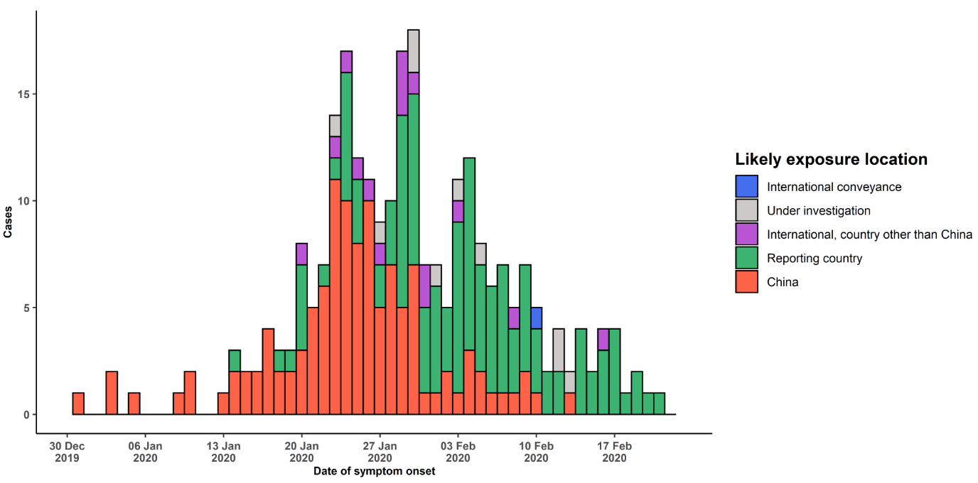

Note for figure 2: Of the 1402 cases reported outside China, 30 were detected while apparently asymptomatic. For the remaining 1372 cases, information on date of onset is available only for the 261 cases presented in the epidemiologic curve.

Figure 3. Epidemic curve of COVID-19 cases (n=1402) identified outside of China, by date of report and likely exposure location, 22 February 2020

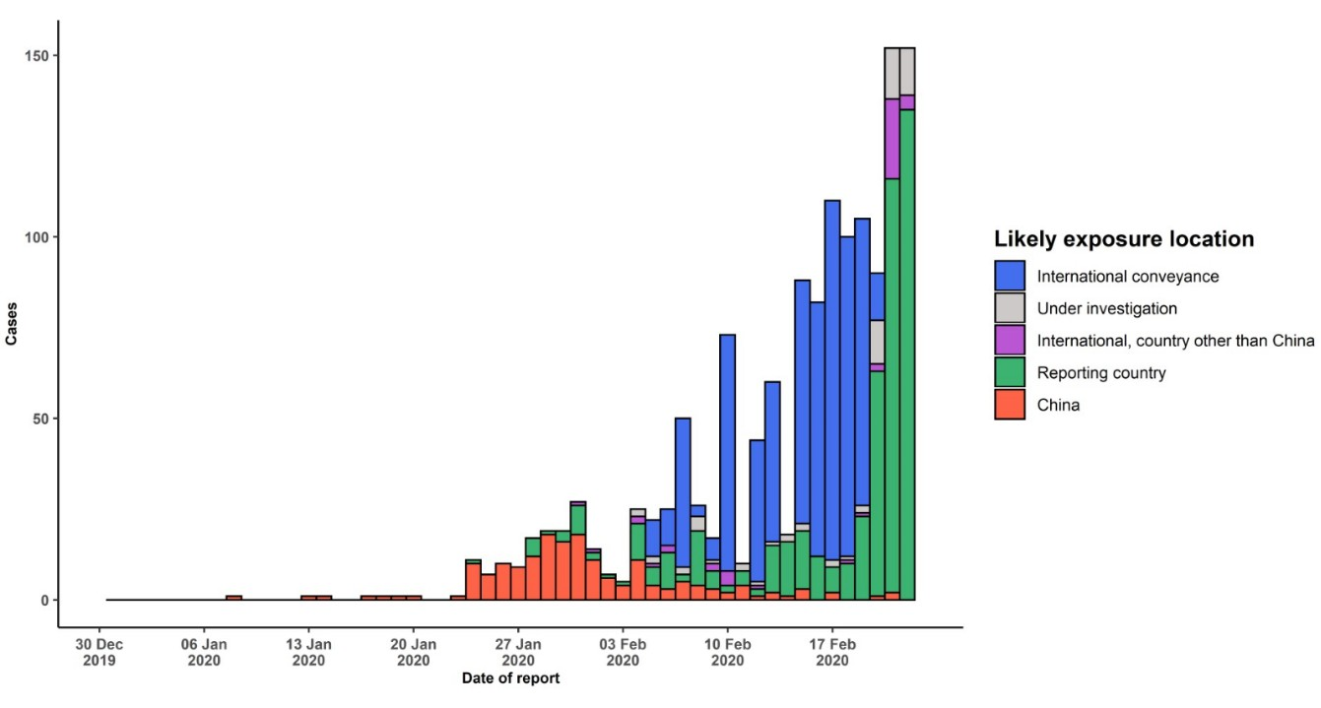
STRATEGIC OBJECTIVES

WHO’s strategic objectives for this response are to:

- Limit human-to-human transmission including reducing secondary infections among close contacts and health care workers, preventing transmission amplification events, and preventing further international spread from China*;
- Identify, isolate and care for patients early, including providing optimized care for infected patients;
- Identify and reduce transmission from the animal source;
- Address crucial unknowns regarding clinical severity, extent of transmission and infection, treatment options, and accelerate the development of diagnostics, therapeutics and vaccines;
- Communicate critical risk and event information to all communities and counter misinformation;
- Minimize social and economic impact through multisectoral partnerships.

*This can be achieved through a combination of public health measures, such as rapid identification, diagnosis and management of the cases, identification and follow up of the contacts, infection prevention and control in health care settings, implementation of health measures for travelers, awareness-raising in the population and risk communication.

PREPAREDNESS AND RESPONSE

- To view all technical guidance documents regarding COVID-19, please go to this webpage.
- WHO is working closely with International Air Transport Association (IATA) and have jointly developed a guidance document to provide advice to cabin crew and airport workers, based on country queries. The guidance can be found on the IATA webpage.
- WHO has developed a protocol for the investigation of early cases (the “First Few X (FFX) Cases and contact investigation protocol for 2019-novel coronavirus (2019-nCoV) infection”). The protocol is designed to gain an early understanding of the key clinical, epidemiological and virological characteristics of the first cases of COVID- 19 infection detected in any individual country, to inform the development and updating of public health guidance to manage cases and reduce potential spread and impact of infection.
- WHO has been in regular and direct contact with Member States where cases have been reported. WHO is also informing other countries about the situation and providing support as requested.
- WHO has developed interim guidance for laboratory diagnosis, advice on the use of masks during home care and in health care settings in the context of the novel coronavirus (2019 -nCoV) outbreak, clinical management, infection prevention and control in health care settings, home care for patients with suspected novel coronavirus, risk communication and community engagement and Global Surveillance for human infection with novel coronavirus (2019-nCoV).
- WHO has prepared disease commodity package that includes an essential list of biomedical equipment, medicines and supplies necessary to care for patients with 2019-nCoV.
- WHO has provided recommendations to reduce risk of transmission from animals to humans.
- WHO has published an updated advice for international traffic in relation to the outbreak of the novel coronavirus 2019-nCoV.
- WHO has activated of R&D blueprint to accelerate diagnostics, vaccines, and therapeutics.
- WHO has developed online courses on the following topics: A general introduction to emerging respiratory viruses, including novel coronaviruses (available in French, Chinese, and Spanish); Critical Care of Severe Acute Respiratory Infections; and Health and safety briefing for respiratory diseases - ePROTECT
- WHO is providing guidance on early investigations, which are critical to carry out early in an outbreak of a new virus. The data collected from the protocols can be used to refine recommendations for surveillance and case definitions, to characterize the key epidemiological transmission features of COVID-19, help understand spread,
severity, spectrum of disease, impact on the community and to inform operational models for implementation of countermeasures such as case isolation, contact tracing and isolation. Several protocols are available here: https://www.who.int/emergencies/diseases/novel-coronavirus-2019/technical-guidance/early-investigations
- WHO is working with its networks of researchers and other experts to coordinate global work on surveillance, epidemiology, modelling, diagnostics, clinical care and treatment, and other ways to identify, manage the disease and limit onward transmission. WHO has issued interim guidance for countries, which are updated regularly.
- WHO is working with global expert networks and partnerships for laboratory, infection prevention and control, clinical management and mathematical modelling.

RECOMMENDATIONS AND ADVICE FOR THE PUBLIC

During previous outbreaks due to other coronavirus (Middle-East Respiratory Syndrome (MERS) and Severe Acute Respiratory Syndrome (SARS), human-to-human transmission occurred through droplets, contact and fomites, suggesting that the transmission mode of the COVID-19 can be similar. The basic principles to reduce the general risk of transmission of acute respiratory infections include the following:

- Avoiding close contact with people suffering from acute respiratory infections.
- Frequent hand-washing, especially after direct contact with ill people or their environment.
- Avoiding unprotected contact with farm or wild animals.
- People with symptoms of acute respiratory infection should practice cough etiquette (maintain distance, cover coughs and sneezes with disposable tissues or clothing, and wash hands).
- Within health care facilities, enhance standard infection prevention and control practices in hospitals, especially in emergency departments.
WHO does not recommend any specific health measures for travellers. In case of symptoms suggestive of respiratory illness either during or after travel, travellers are encouraged to seek medical attention and share their travel history with their health care provider.

